Variant 1.

1. Your roommate has noticed that you now spend most of your time studying microbiology and has become curious about the subject. She asks you to explain in the simplest possible way how prokaryotes differ from eukaryotes.
- What do you tell her?

2.
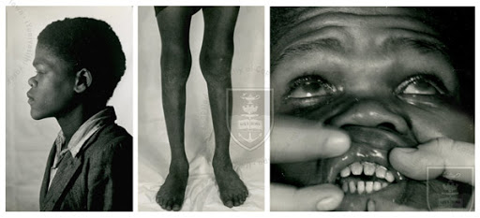
- A 7-year-old male patient has next symptoms: Hutchinson’s triad which is characterized by pegshaped upper central incisors (teeth), and interstitial keratitis which consists of blurred vision, abnormal tearing, eye pain and abnormal sensitivity to light,eighth nerve deafness, saddle nose, bony prominence of the forehead, a sharp anterior bowing, or convexity, of the tibia.
- Symptoms of what infectious disease is shown in the picture?
- What is the causative agent of this disease?
- Indicate their taxonomic position, describe the characteristic properties and epidemiology of the causative agent.

Variant 2.

1. It is needed in bacteriologic laboratory to define morphology and motility of an isolated pure culture of bacteria. For this purpose, a laboratory assistant prepares 2 types of smears: 1) lining specimen slides and 2) heat-fixed-specimen slides of microorganism.
- What kind of smear is intended for staining? Why?
- What smear requires special precautions to prevent contamination of the staff and environment during microscopy? Why?

2. A 35-year-old male patient presented to a private clinic with a chief complaint of pain in his lower left back tooth region of the jaw and numbness in the chin for the past five days. He started having pain due to grossly decayed teeth in the left lower back tooth region, for which he underwent extraction of the lower left second premolar and the first molar. A gauze pack that had been placed in the socket post-extraction had been mistakenly left in place by the patient for one week. The patient experienced dull pain in the same region; he was prescribed broad-spectrum antibiotics, but the pain persisted.
Upon extraoral examination, all findings were normal except for non-tender, enlarged lymph nodes. On intraoral examination of the area of the chief complaint, the unhealed extraction socket was found to be filled with slough and debris and showed exposed buccal and lingual cortices. The adjacent tooth displayed gingival recession and inflammation. Palpation revealed that the lesioned area was tender, and the pain intensity was high. The tissue was sent for histopathological examination.
Upon histopathological assessment, the H&E-stained (hematoxylin and eosin) section showed the presence of bone and connective tissue components with dense and diffuse inflammatory cell infiltration. Filamentous branching cells of gram-positive, nonmotile bacteria were revealed in the the smear. The filamentous cells of this microorganism was arranged in form mycelium that is similar to a mycelium of fungi. 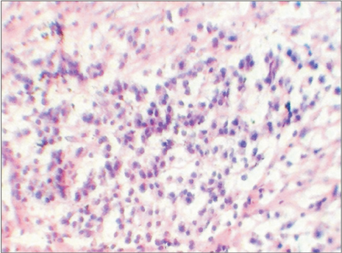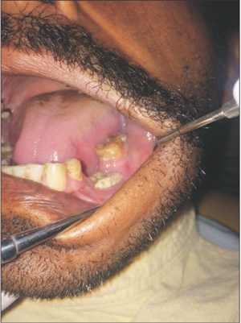
1. What infection disease do you suspect?
2. What are the possible causative agents of this disease? Indicate their taxonomic position, describe the characteristic properties of the main causative agent.

Variant 3.

1. Explain the diagram with describing what and why will happen to a bacterial cell when it is placed in:
(a) Isotonic solution
(b) Hypotonic solution
(c) Hypertonic solution

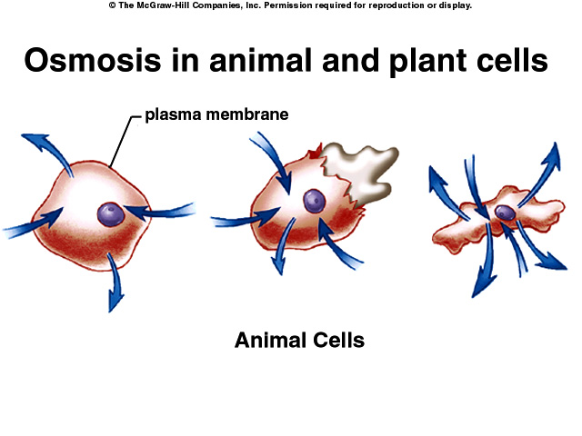
(a) (b) (c)

2. Patient A is 19 years of age and a college sophomore who presented to her physician's office with mild jaundice. The patient reports being in good health until a week before, at which time she began having flu-like symptoms of headache, low-grade fever, nausea, loss of appetite, and malaise. She self-treated the fever with acetaminophen. The symptoms persisted. Upon awakening this morning, she noticed that her eyes were yellow. She therefore contacted her physician's office.
In response to her physician's questions, she indicated that her urine has been darker than usual and she has been experiencing joint pain for the last three days. She also acknowledged that her stools have been lighter than usual.
She was immunized against hepatitis B at 12 years of age and she recently participated in a two-week mission trip to Central America. Although she was very cautious about the foods, she ingested during the mission trip, the patient indicated that a primary recreational activity after the day's work was to swim in the lagoon near the village. The lagoon was fed both by the stream in which the natives washed their clothes and the adjacent bay. Patient A returned to the United States five weeks ago.
- What infection disease do you suspect?
- What are the possible causative agents of this disease, indicate their taxonomic position, describe the characteristic properties of the main causative agent.
3. What methods of laboratory diagnostics are used? Which method will you choose to confirm the diagnosis? Describe it.

Variant 4.

1. At a practical work of microbiology a student needs to stain a slide smear of isolated bacteria to study their morphology and structural peculiarities.
- What stain should he to use?
- What structural component of bacterial cell may be revealed?
- What stage of this staining does difference in cell wall structure reveal?

2.

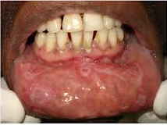
A 35-year-old male patient was initially seen at primary healthcare centers complaining of multiple painful lesions in the mouth as their main health problem, and went through the medical diagnostic protocol. HIV and hepatitis C exams requested were negative. The most common fundamental lesions were plaques on the mucosa, ulcers, nodules, spots, and erosion, in this order. The most affected anatomical sites included labial mucosa, tongue edge, hard and soft palates, lip commissure, ventral tongue, uvula, and tonsils, respectively. The plaques from the mucosa was investigated by microscopic method. The pale pink spiral motile bacteria was detected in the smear stained by Giemsa method.
1. What infectious disease of oral cavity is shown in the photo?
2. What is the causative agent of this disease, indicate their taxonomic position, describe the characteristic properties of the main causative agent.
3. What methods of laboratory diagnostics are used? Which method will you choose to confirm the diagnosis? Describe it.

Variant 5.

1. Microscopical examination of the pus from a patient wound reveal Gram-positive cocci placed as a grape-like conglomeration (see photo below).

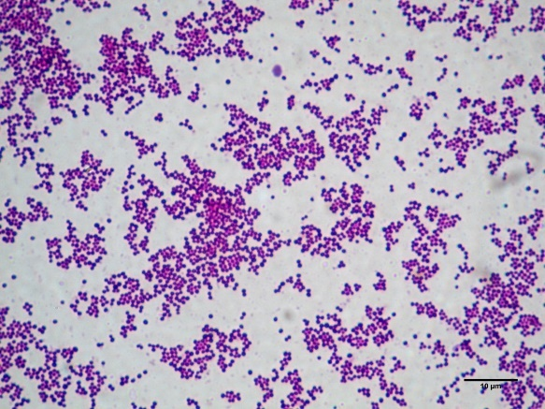
- Name bacteria shown on this photo.

2.
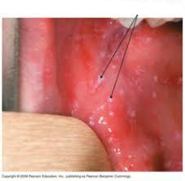
1. What symptom is shown in the photo? It are slightly raised white dots, d=2-3 mm on the inside of the cheeks that occur before 24-36 h of skin rash appears
2. What infectious disease is this symptom characterized for?
3. What is the possible causative agent of this disease, indicate their taxonomic position, describe the characteristic properties of the main causative agent.
4. What methods of laboratory diagnostics are used? Which method will you choose to confirm the diagnosis? Describe it.

Variant 6.

1. A 21-year-old student was seen by his family physician with complaints of pharyngitis. Examination of the pharynx revealed patchy erythema and exudates on the tonsillar pillars. Throat smear showed gram-positive cocci in chains (see photo below)

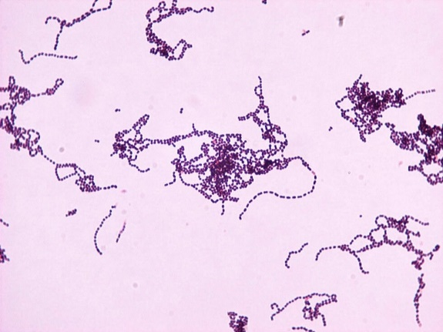
- Name the morphological group bacteria.

2. 2. A 16-year-old previously well girl presented with a fever for two or three days and with a left-sided facial swelling that had arisen within the previous 24 hours. She denied any dental problems. On examination, she had an obvious large tender swelling of the left side of her face. She was generally unwell.
She had received MMR vaccination at 13 months and then at age six had been vaccinated with MR in the catch-up program.
- What is the causative agent of this disease, indicate their taxonomic position, describe the characteristic properties of the main causative agent.
- What methods of laboratory diagnostics are used? Which method will you choose to confirm the diagnosis? Describe it.

Variant 7.

1. Microscopical examination of a slide smear stained by Giemsa reveals corkscrew-shaped bacterium of pale-pink color (see photo).
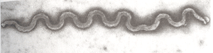

- What infectious disease does it cause?
- Name this germ in Latin.

2. A six-year-old boy came in to the doctors because he started developing a rash on his body. He said it started appearing on his face and it spread out throughout his body. His mother thought it was chicken pox, but a few days later the boy started experiencing a fever. He was coughing, had a runny nose, and his eyes were watering.
- What is the causative agent of this disease, indicate their taxonomic position, describe the characteristic properties of the main causative agent?
- What methods of laboratory diagnostics are used? Which method will you choose to confirm the diagnosis? Describe it.

Variant 8.

1. The sample of feces from a patient with dysbacteriosis was microscopically examined. There were large ovoid Gram-positive cells detected in smear (see photo).

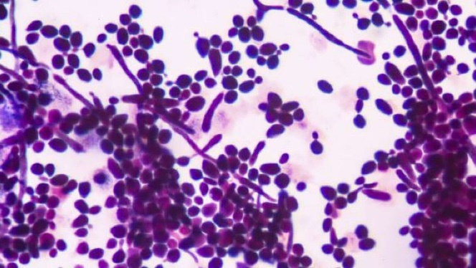
- Name the microorganism revealed in microscopy.

2. See the scheme and answer the questions below:

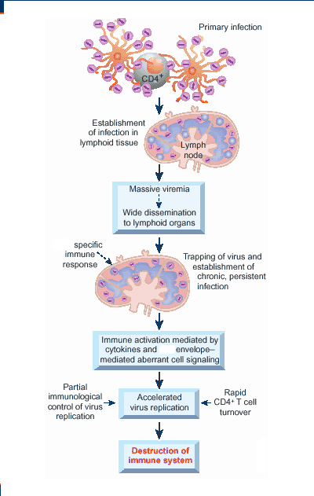
- Pathogenesis of what infection disease is shown in the picture?
- What is the causative agent of this disease, indicate their taxonomic position, describe the characteristic properties of the main causative agent.
- What methods of laboratory diagnostics are used? Which method will you choose to confirm the diagnosis? Describe it.

Variant 9.
1. In microscopy of a drop of blood from the patient with fever were coiled bacteria observed: they had 5-8 large irregular coil, and had blue-violet color under the Giemsa staining (see photo)

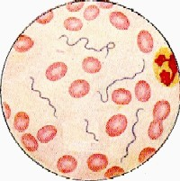
- Name the Genus of these bacteria.

2. A previously healthy 14-year-old female presents to the emergency department with three days of progressive facial and neck swelling. The swelling started on the left side. Two days ago, she visited her primary care physician where it was established, she had swelling of the salivary gland and mumps IgM testing. She is fully vaccinated, but was exposed to a mumps outbreak at school.
- What is the causative agent of this disease, indicate their taxonomic position, describe the characteristic properties of the main causative agent?
- What methods of laboratory diagnostics are used? Which method will you choose to confirm the diagnosis? Describe it.

Variant 10.

1. A sample of feces from the child complained on abdominal ache and diarrhea was inoculated on the Endo medium plate. In a day of growth red colony of bacteria were observed on the medium.
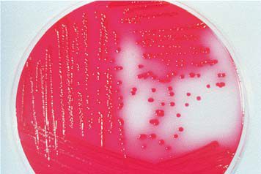
- What species of bacterium is suspected to be grown? Explain your answer.

2. A pregnant 18-year-old woman came to the Ford County urgent-care clinic with a low-grade fever, malaise, and headache. She was sent home with a diagnosis of influenza. She again sought treatment 7 days later with a macular rash on her trunk, arms, hands, and feet. Further questioning of the patient when serology results were known revealed that I month previously, she had a painless ulcer on her vagina that healed spontaneously.
- What bacterial diseases can cause rashes, indicate their taxonomic position? Describe the characteristic properties of the main causative agent.
- What serologic tests are used to diagnose these infections?
- What are the consequences of not treating this infection?

