Federal State Budgetary Educational Institution of Higher Education "Astrakhan State Medical University" of the Ministry of Health of the Russian Federation
Department of Otorhinolaryngology and Ophthalmology

2019-2020 academic year

Specialty: General Medicine

Discipline: Ophthalmology

Developers: Ramazanova L.Sh., Napylova O.A., Shamratov R.Z.
Astrakhan 2020

Situational task №1

Assessed competencies: PK-6, PK-8, PK-10

Patient K., 25 years old, complained of redness of the mucous membrane of both eyes, gluing eyelashes, especially in the morning, a feeling of a “foreign body” under the eyelids. He fell ill three days ago after swimming in the lake. When examining the conjunctiva of the eyelids and eyeballs, it is sharply hyperemic, moderately edematous, there are single follicles on the conjunctiva of both eyes, moderate purulent discharge.

Questions

1. What disease do you suspect in this patient.
2. What survey methods need to be carried out additionally
3. With what it is necessary to carry out differential diagnostics for this pathology
4. What is the tactics of your further actions
5. Treatment
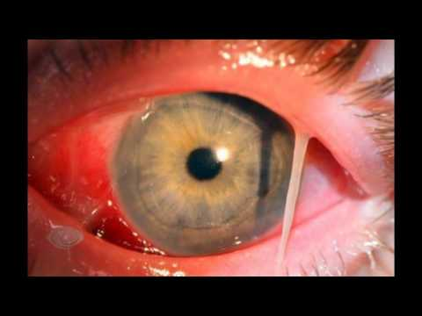

Situational task №2

Assessed competencies: PK-6, PK-8, PK-10

A 35-year-old patient D. complains of redness and pain in the inner part of the lower eyelid of the left eye, fever up to 37.8, headache, weakness, and malaise. Notes that 5 days ago the upper teeth hurt on the same side. After treatment at home, the toothache gradually subsided.
On examination, marked hyperemia of the skin, swelling of the lower eyelid of the left eye, more pronounced in the area of ​​the projection of the lacrimal sac; on palpation, soreness and secretion of mucus and pus through the lower lacrimal opening are also noted here. There is a moderate injection of conjunctival vessels, swelling of the mucous membrane of the lower eyelid and the eyeball. The right eye is healthy.

Questions

1. What disease do you suspect in this patient?
2. What survey methods need to be carried out additionally
3. What is the treatment tactic

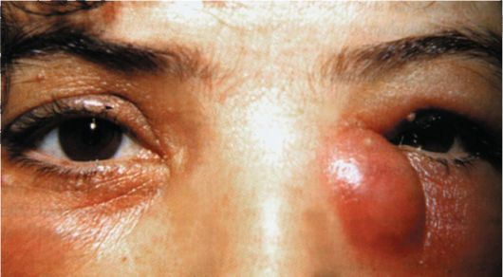

Situational task №3

Assessed competencies: PK-6, PK-8, PK-10

Patient M., 42 years old, complained of redness, limited painful swelling and swelling along the edge of the upper eyelid of the left eye for three days.
On examination, moderate swelling of the upper eyelid, hyperemia and swelling of the conjunctiva of the upper eyelid are noted. From the anamnesis it turned out that over the past two years this has been repeated for the fourth time.

Questions

1. What disease do you suspect in this patient?
2. What survey methods need to be carried out additionally
3. What is the treatment tactic

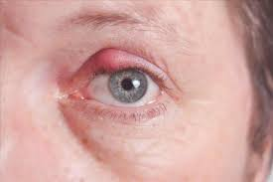

Situational task №4

Assessed competencies: PK-6, PK-8, PK-10

Patient V., 55 years old, complained of redness, thickening of the edges of the eyelids, itching, a feeling of clogging in the eyes, eye fatigue with prolonged visual load near, periodic redness of the eyes with the appearance of acrid foamy discharge in the corners of the palpebral fissure of both eyes. Sick for three years.

Questions

1. What eye disease do you suspect in a patient
2. What are the most common causes of this disease
3. What are the possible complications of this pathology?
4. What will be the tactics of treatment

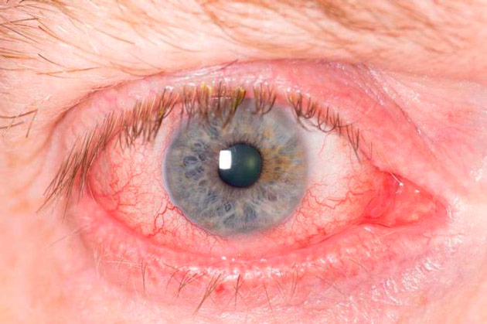

Situational task №5

Assessed competencies: PK-6, PK-8, PK-10

Patient D., 15 years old, a few weeks ago appeared on the upper eyelid of his left eye with a tumor-like formation about the size of a pea. The skin above the tumor is mobile. The formation itself is soldered to the underlying tissues. From the side of the conjunctiva, it shines through in a grayish color, around the conjunctiva it is thickened and hyperemic. Palpation of the tumor is painless. Visual acuity of both eyes = 1.0

Questions

1. What eye disease do you suspect in a patient
2. What are the most common causes of this disease
3. What will be the tactics of treatment

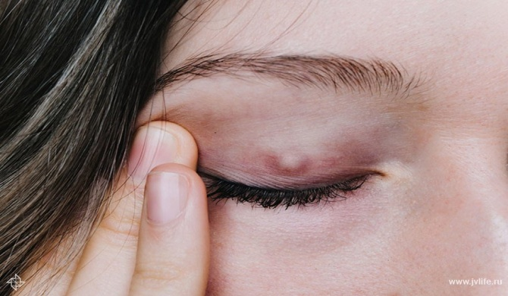

Situational task number 6

Assessed competencies: PK-6, PK-8, PK-10

Patient L., 14 years old, walks with his head thrown back high. The upper eyelids of both eyes are lowered. Visual acuity of both eyes = 1.0. The eyes are healthy.

Questions

1. What eye disease do you suspect in a patient
2. What is the name of the forced position of the head in this disease?
3. What will be the tactics of treatment

Situational task №7

Assessed competencies: PK-6, PK-8, PK-10

Child H., 9 years old, a few days ago appeared redness, a feeling of clogging in both eyes. When contacting an optometrist objectively. Visual acuity of both eyes = 0.9 (not corr.). Swelling of the eyelids and pinpoint hemorrhages on the conjunctiva of the sclera are noted. On the mucous membrane of the eyelids and lower arch there are whitish-gray films that are easily removed with moist cotton. After their removal, the loosened, but not bleeding, tissue of the conjunctiva is exposed. In the surface layers of the perilimbal region, small infiltrates, sometimes eroded. Subordinate parts of the eye without visible pathology.

Questions

1. What eye disease do you suspect in the patient
2. What will be the tactics of treatment

Situational task №8

Assessed competencies: PK-6, PK-8, PK-10

Child F., 7 years old, has a sore throat. Against the background of this disease, a pronounced swelling appeared, and hyperemia in the outer part of the upper eyelid of the left eye. This area is somewhat painful on palpation. The conjunctiva of the eyeball is injected and somewhat swollen in the upper-outer section. The eyeball is shifted down and inside; its mobility is somewhat limited. Visual acuity of the right eye = 1.0. The front section is not changed. Optical media are transparent. The fundus is normal. The child has a fever.

Questions

1. What eye disease do you suspect in a patient
2. What will be the tactics of treatment

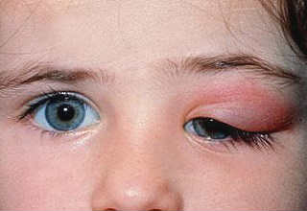

Situational task №9

Assessed competencies: PK-6, PK-8, PK-10
Almost from the moment of birth, baby S., 6 months old, suffers from conjunctivitis of the left eye. It is periodically treated with short-term improvement. Purulent discharge from the eye almost completely does not disappear. Conducted antibacterial and anti-inflammatory treatment is ineffective. Objectively. Slight swelling and hyperemia of the edges of the eyelids. Cilia are glued into bundles with shriveled pus (more at the medial corner of the eye). Purulent discharge from the eye. Lacrimation. The conjunctiva of the eyelids is moderately injected. The eye is almost calm. Optical media are transparent. The fundus is normal.
Questions

1. What eye disease do you suspect in the patient?
2. What will be the tactics of treatment?
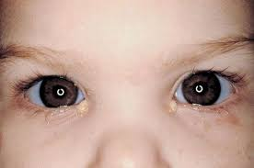

Situational task number 10

Assessed competencies: PK-6, PK-8, PK-10

Patient K., 48 years old, complained of film formation at the inner corner of the left eye, growing on the cornea. From the anamnesis: the film grew gradually, about 2 years, did not contact the ophthalmologist. On examination: the presence of a degenerative fibrovascular film of the conjunctiva, which is 4 mm beyond the edge of the limb, is determined at the inner corner. Optical media are transparent. The fundus is normal.
Questions
1. What disease do you suspect in this patient?
2. What examination methods need to be carried out additionally?
3. What is the tactic of your further actions? Treatment?
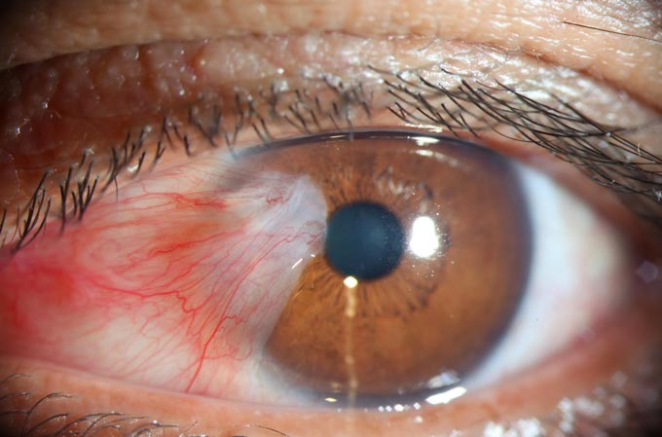
Situational task № 11

Assessed competencies: PK-6, PK-8, PK-10

Patient P., 76 years old, complains of lacrimation, redness of both eyes, decreased vision. Suffers from chronic conjunctivitis, for which he regularly receives treatment. Objective data: Lower eyelids droop down. The costal margins are not adjacent to the eyeball. The conjunctival surface of the eyelid is exposed. The conjunctiva is hypertrophied in the lower arch. The lacrimal openings are turned out. Conjunctival injection of the eyeball. Anterior segment of eyes without visible changes. The fundus is normal.
Questions:
1. Make a diagnosis.
2. What are the therapeutic measures.

Situational task № 12

Assessed competencies: PK-6, PK-8, PK-10

The disease in patient L., aged 19, began first in one eye and then in the other. Complaints of clogging, itching and burning in the eye, redness and the presence of discharge from the eye. In the morning, the eyelids are glued together with dried pus. Objectively. Visual acuity of both eyes = 0.9 (not corr.). The eyelids are somewhat swollen. On the eyelashes, single crusts of dried pus. Severe conjunctival injection of the eyeball. The conjunctiva is slightly swollen, thickened. On the upper eyelid hypertrophy of the papillae. In the conjunctival arch veins of pus. Front segments of eyes are not changed. Optical media are transparent. The fundus is normal.
Questions:
1. Make a diagnosis.
2. What are the therapeutic measures.
3. What are the preventive measures.

Situational task № 13

Assessed competencies: PK-6, PK-8, PK-10
Patient M., 39 years old, complains of severe swelling and flushing of the eyelids of the right eye, profuse purulent discharge and the inability to open the eye. The patient notes a rise in temperature to 37.8 ° and muscle pain. Objectively: the left eye is healthy, visual acuity = 1.0. The visual acuity of the right eye is 0.1 (does not correct). Biomicroscopy: severe edema and hyperemia of the eyelids. Eyelids are soft to the touch, testy. From the palpebral fissure, profuse purulent discharge of yellow color, creamy consistency. The conjunctiva is swollen, loosened. On the cornea, surface erosion and a small infiltrate. Subordinate departments without visible pathology.

Questions:
1. Make a diagnosis.
2. What additional research is needed?
3. What are the therapeutic measures.

Situational task No. 14

Assessed competencies: PK-6, PK-8, PK-10

Patient T., 53 years old, complains of constant lacrimation from the left eye, worse on the street. These complaints have been troubling for 3 years. Objectively: Visual acuity of the left eye = 1.0. The position of the eyelids and lacrimal openings is correct, when pressing on the area of ​​the lacrimal sac - there is no discharge. There is lacrimation. Color lacrimal test negative. When washing the lacrimal passages, the liquid does not pass into the nose, it returns through the upper lacrimal opening. The eye is calm. Optical media are transparent. The fundus without pathology. TOS = 19 mmHg Art.
Visual acuity of the right eye = 1.0. The eye is healthy. The lacrimal test is positive, when washing the liquid passes freely into the nose.
TOD = 18 mmHg Art.

Questions:
1. Make a diagnosis.
2. What are the therapeutic measures.

Situational task № 15

Assessed competencies: PK-6, PK-8, PK-10
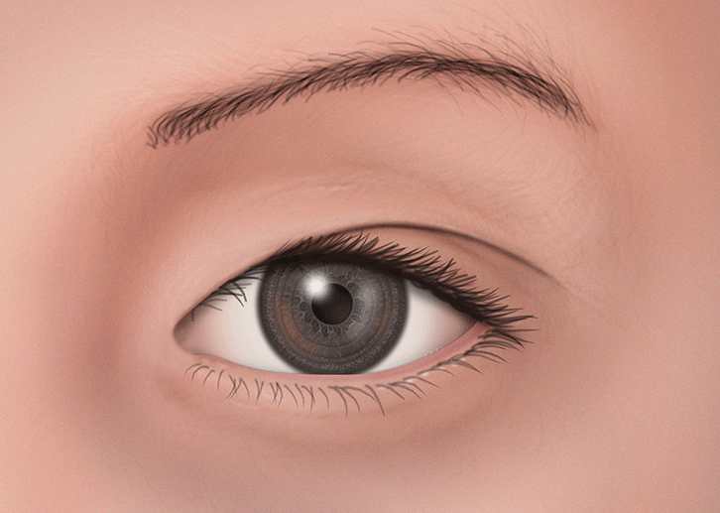
The girl is 4.5 years old. Parents are concerned about the unusual structure of the child’s eyes
( picture 1).
Parents also express their concern about the apparent strabismus in the girl. Objectively: The visual acuity of both eyes is 0.9 without correction.
Questions:
1. Make a preliminary diagnosis.
2. How to clarify the issue of strabismus?
3. What are the recommendations for treatment.

