Federal State Budgetary Educational Institution of Higher Education "Astrakhan State Medical University" of the Ministry of Health of the Russian Federation
Department of Otorhinolaryngology and Ophthalmology

2019-2020 academic year

Specialty: General Medicine

Discipline: Ophthalmology

Developers: Ramazanova L.Sh., Napylova O.A., Shamratov R.Z.
Astrakhan 2020

Situational task №1

Assessed competencies: PK-6, PK-8, PK-10

Patient R. complained of dryness, burning, itching, pain in the eyes, photophobia, decreased eyesight in both eyes, an almost complete absence of tears even during crying, dry skin and in the oral cavity, swelling and stiffness in the joints of the hands and legs.
Sick for 8 months. On examination, a moderate mixed injection of the conjunctiva of both eyes is noted, scanty, viscous, filiform discharge. Across the cornea there is moderate swelling, small-dot infiltrates, superficial opacities, thin mucous filaments stretch from the cornea to the conjunctival arch.

Questions

1. What disease do you suspect in this patient?
2. What survey methods need to be carried out additionally
3. What is the treatment tactic
4. What complications can be with this pathology

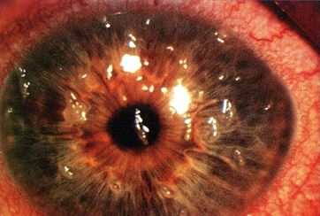

Situational task №2

Assessed competencies: PK-6, PK-8, PK-10
Patient L., 20 years old, complains of lacrimation, a feeling of a foreign body of the left eye. In the morning in the garden a tree branch “hit” on the face. Objectively. Mild swelling of the eyelids with symptoms of blepharospasm. Visual acuity of the left eye = 0.6 (not corr.). Lacrimation. The eyeball is poorly injected pericorneal type. The surface of the cornea seems rough, an epithelial defect in the optical area of ​​the cornea is determined. Subordinate departments and fundus without visible pathology. The right eye is healthy.

Questions

1. What disease do you suspect in this patient?
2. What survey methods need to be carried out additionally
3. What is the treatment tactic
4. What complications can be with this pathology

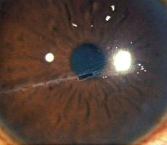

Situational task №3

Assessed competencies: PK-6, PK-8, PK-10
A 35-year-old man R., while working in the garden, got a piece of land in his right eye. When contacting an ophthalmologist a few days ago, a foreign body was removed from the conjunctiva of the upper eyelid. However, the feeling of a foreign body continues to bother. Vision decreased, marked lacrimation appeared, the patient hardly opens his eye. Objectively. Visual acuity of the right eye = 0.08 (not corr.). Mild edema and hyperemia of the eyelids. Pericorneal injection of the eyeball. The cornea is swollen. Paracentrally on the cornea is an ulcer with an undercut edge. In the anterior chamber, the level of pus is 2 mm. The iris is swollen, its pattern is stained. In transmitted light, a red reflex. Details of the fundus cannot be considered.

Questions

1. What disease do you suspect in this patient?
2. What survey methods need to be carried out additionally
3. What is the treatment tactic
4. What complications can be with this pathology

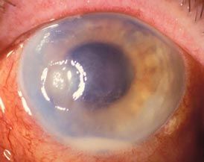

Situational task №4

Assessed competencies: PK-6, PK-8, PK-10

Patient R., 34 years old, turned to an ophthalmologist with complaints of redness of the right eye, pain in the eye and a feeling of a foreign body. Sick about 10 days. I did not contact a doctor during this time.
Objectively: Visual acuity of the right eye = 0.04 (not corr.). Moderate edema and hyperemia of the eyelids. Mixed injection of the eyeball. The cornea in the center is ulcerated, at the bottom of the ulcer is a small black vesicle. The edges of the ulcer are infiltrated. The cornea is swollen. At the bottom of the anterior chamber is a strip of pus. The iris pattern is faded. Subordinate parts of the eye are not visible due to decreased transparency of the cornea. Visual acuity of the left eye = 1.0. The eye is healthy.

Questions

1. What disease do you suspect in this patient?
2. What is the treatment tactic
3. What complications can be with this pathology

Situational task №5

Assessed competencies: PK-6, PK-8, PK-10

Patient G., 22 years old, complains of lacrimation, photophobia and a feeling of a foreign body in the left eye. The disease began about 4 days ago. Objectively. Visual acuity of the right eye = 0.5 (not corr.). Severe pericorneal injection of the eyeball. On the cornea, the gray infiltrate in the form of a tree branch is stained with fluorescein. Subordinate parts of the eye without visible pathology. The right eye is healthy.

Questions

1. What disease do you suspect in this patient?
2. What is the treatment tactic
3. What complications can be with this pathology

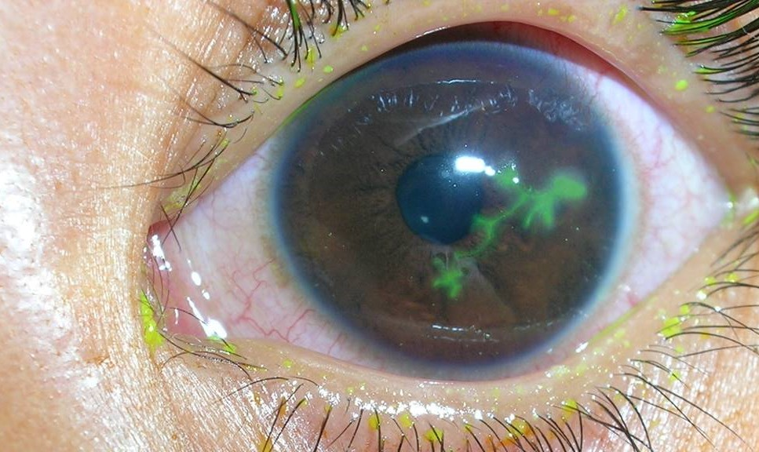

Situational task number 6

Assessed competencies: PK-6, PK-8, PK-10

Patient D., 27 years old, complains of redness of the right eye. About a week is treated for conjunctivitis without positive dynamics. Currently objective. Visual acuity of both eyes = 1.0. With lateral lighting, hyperemia and thickening of the conjunctiva is determined. Hyperemia is local in nature, in the outer part the focus of inflammation 2.0 x 1.5 cm in size is bright red, with a purple hue, as if raised above the surface of the sclera. Palpation is painful. The remaining parts of the eye are not changed.

Questions

1. What disease do you suspect in this patient?
2. What is the treatment tactic
3. What complications can be with this pathology

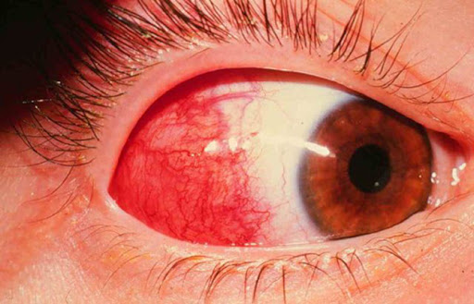

Situational task №7

Assessed competencies: PK-6, PK-8, PK-10

Patient C., 19 years old, complains of low vision of the left eye. From the anamnesis: suffered viral keratitis of the left eye 2 years ago. It was treated for a long time, relapses of the disease were observed.
Currently objective. Visual acuity of the right eye = 1.0. The eye is healthy. Visual acuity of the left eye = 0.06 (not corr.). The eyeball is not injected. From the limb to the center, bright red vessels grow in the cornea, which branch and anastomose between themselves. In the center of the cornea there is limited clouding of gray-white color, irregular shape. The peripheral parts of the cornea are transparent. The underlying parts of the eye are not changed.

Questions

1. What disease do you suspect in this patient?
2. What is the treatment tactic

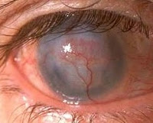

Situational task №8

Assessed competencies: PK-6, PK-8, PK-10

Patient R., 18 years old, complained of visual impairment in both eyes, more pronounced on the right. From the anamnesis: vision began to decline about three years ago, did not consult a doctor.
Objectively. Visual acuity of the right eye = 0.05 with a sphere of 6.5 diopters. and a cylinder - 2.75 diopters. axis 70 ° = 0.2. The eye is calm. Gentle clouding of the cornea in the center, there is some "sharpening" of the cornea. Medium depth front camera with clear moisture. Subordinate parts of the eye without visible pathology. Visual acuity of the left eye = 0.1 with a sphere of 2.0 diopters. and a cylinder - 2.5 diopters axis 75 ° = 0.6. The eye is calm. There are no visual changes in the eyeball. Right eye refractometry fails due to blurry marks. On the left, complex myopic astigmatism is defined.

Questions

1. What disease do you suspect in this patient?
2. What additional research needs to be done
3. What is the treatment tactic

SITUATIONAL PROBLEM № 9

Assessed competencies: PK-6, PK-8, PK-10
Patient R., 62 years old, complained of photophobia, lacrimation, painful sensation of a foreign body over the eyelids, blurred vision and redness of the right eye. The listed symptoms appeared 3 days after an accidental injury to the left eye with a branch. Immediately after the injury, he did not consult a doctor. On examination: Visus OS = 1.0, ocular status without pathology. Visus OD = 0.2 (does not correct), palpebral fissure narrowed, pronounced mixed injection of the eyeball. In the optical zone of the cornea is determined rounded infiltrate 2x1 mm yellow-green with a depression in the center and fuzzy borders, stained with fluorescein. The moisture of the anterior chamber is cloudy, at the bottom its pus level is 2 mm. The iris has a greenish tint (on the healthy eye, the iris is blue), the pupil is narrowed, photoreactions are reduced. Palpation of the eyeball is sharply painful.

Question:
1. Make a diagnosis.
2. Define treatment tactics.
3. What are the possible complications?

SITUATIONAL PROBLEM № 10

Assessed competencies: PK-6, PK-8, PK-10
Patient D., 19 years old, complained of redness of both eyes, a foreign body sensation behind the eyelids, photophobia and lacrimation, eyelid adhesion in the morning, slight narrowing of the eye gap due to swelling of the eyelids, swelling of the lower transitional and lunate folds, conjunctival injection and scanty mucous discharge in the conjunctival cavity, large follicles in the conjunctiva of the lower eyelid, subepithelial rounded “coin-like” infiltrates in the cornea. Visual acuity of both eyes 0.8 is not corrected.
Question:
1. Make a diagnosis.
2. What is the etiology, pathogenesis, clinical forms of this disease.
3. What diseases should be used for differential diagnosis? Does this disease have?
4. Define treatment tactics.
5. What are the preventive measures.

SITUATIONAL PROBLEM № 11

Assessed competencies: PK-6, PK-8, PK-10

Patient R., 12 years old, complains of pain in the left eye, lacrimation, photophobia, blepharospasm. From the anamnesis: in early childhood, the patient suffered rheumatism. Objectively: with biomicroscopy, a limited area of ​​conjunctival hyperemia is determined, which rises above the rest of the surface of the eyeball. The sclera underneath has a bluish-red hue. Palpation of this area is sharply painful. The visual acuity of both eyes is 1.0. Optical media are transparent. The fundus without pathology.
Question:
1. Make a diagnosis.
2. What is the etiology of this disease?
3. What are the tactics of treatment and prognosis.

SITUATIONAL PROBLEM № 12

Assessed competencies: PK-6, PK-8, PK-10

Patient R., 19 years old, complained of visual impairment in both eyes, more pronounced on the left. From the anamnesis: vision began to decline gradually about three years ago, wears spherical glasses -3.0 diopters in both eyes.
Objectively. Visual acuity of the right eye = 0.06 with a sphere of 3.5 diopters. and a cylinder - 1.0 diopters. axis 60 ° = 0.8. The eye is calm. There are no visual changes in the eyeball. Optical media are transparent. Subordinate parts of the eye without visible pathology. Refractometry: complex myopic astigmatism is determined. Visual acuity of the left eye = 0.1 with a sphere of 5.5 diopters. and a cylinder - 3.25 diopters axis 75 ° = 0.2. Gentle clouding of the cornea in the center, there is some "sharpening" of the cornea. Medium depth front camera with clear moisture. Subordinate parts of the eye without visible pathology. Left eye refractometry fails due to blurry marks.

Question:
1. What disease do you suspect in this patient?
2. What additional research needs to be done?
3. What are the tactics of treatment and prognosis.

SITUATIONAL PROBLEM № 13

Assessed competencies: PK-6, PK-8, PK-10

Patient K., 68 years old, complained of visual impairment of the right eye, “thick fog” in front of the right eye, lacrimation, photophobia, sensation of a “foreign body”.
From the anamnesis: 1 month ago was operated on for cataracts of the right eye. Vision improved after surgery, but then decreased again.
Objectively. Visual acuity of the right eye = 0.02 (does not correct). Biomicroscopy: the cornea is edematous, folds of the descemet sheath, the corneal epithelium is edematous and bullous. Underlying sections of the eye are not visible due to changes in the cornea. Tonometry OD = 19.0 mm Hg
Question:
1. What disease do you suspect in this patient?
2. What are the treatment tactics and prognosis?

