Federal State Budgetary Educational Institution of Higher Education "Astrakhan State Medical University" of the Ministry of Health of the Russian Federation
Department of Otorhinolaryngology and Ophthalmology

2019-2020 academic year

Specialty: General Medicine

Discipline: Ophthalmology

Developers: Ramazanova L.Sh., Napylova O.A., Shamratov R.Z.
Astrakhan 2020

Situational task number 1

Assessed competencies: PK-6, PK-8, PK-10

Patient G, 66 years old, suffered a hypertensive crisis, after which he noticed a decrease in vision in his right eye. Vision decreased sharply, painlessly. Objectively. Visual acuity of the right eye = 0.02 (not corr.). The adnexa is normal. The eyeball is not injected. Anterior segment of the eye with no apparent pathology. Against the background of the red reflex from the fundus, black floating stripes are visible, directed at the apex to the center of the pupil. On the fundus of the optic disc, the eye is edematous, red, its contours are stained, poorly visible due to numerous hemorrhages resembling flames. The veins are dark, dilated, convoluted, sometimes lost in the edematous tissue of the retina. The arteries are narrow. Numerous streaky and large hemorrhages throughout the fundus. Left eye. Visual acuity = 0.5 with spherical glass –2.0 diopters. = 0.9. The adnexa is normal. The eyeball is not injected. Front segment without visible changes. In the transmitted light against the background of the red reflex black strokes are visible, similar to those on the right. On the fundus picture of hypertensive retinal angiosclerosis.

The questions

1. Make a diagnosis.
2. Therapeutic measures.
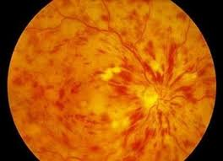

Situational task number 2

Assessed competencies: PK-6, PK-8, PK-10

Patient F., 17 years old, sharply decreased vision in his left eye after lifting weights. He has a short history of myopia. The patient complains of the presence of a dark "curtain" on top. Objectively. Visual acuity of the right eye = 0.02 with a sphere of 6.5 diopters. = 1.0. The eye is calm. Anterior segment without visible pathology. Optical media are transparent. Ophthalmoscopy: optic nerve disc oblique, Myopic cone Peripheral vitreochorioretinodystrophy. Visual acuity of the left eye = 0.01 (not corr.). The eye is completely calm. Anterior segment without visible pathology. Optical media are transparent. In transmitted light, against the background of the red reflex in the lower parts of the eye, a veil-like film of gray color is visible, which sways when the eyeball moves. With ophthalmoscopy. Below you can see the vesicular translucent formation, on which the vessels climb.

The questions

1. Make a diagnosis.
2. What additional research is needed?
3. Treatment, timing.
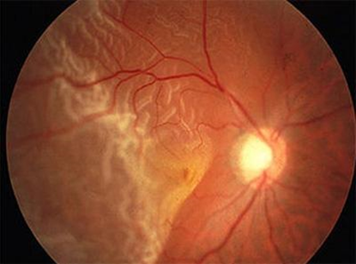

Situational task number 3

Assessed competencies: PK-6, PK-8, PK-10

Patient G., 64 years old, complaints of decreased vision of the right eye. Anamnesis: considers himself ill within 3 days. A week ago suffered acute right-sided sinusitis. Objectively. Visual acuity of the right eye = 0.2 (not corr.). The right eye is calm, the optical media are transparent. The fundus of the eye: the optic nerve disk is hyperemic, its borders are fused, swollen, it is slightly prominently in the vitreous body, the arteries are dilated, the veins are convoluted, the vascular funnel is filled with exudate. The macular region and the periphery of the retina without pathology. TOD = 22 mmHg Visual acuity of the left eye = 1.0. The eye is healthy. TOS = 23 mmHg

The questions

1. Make a diagnosis.
2. What additional research is needed?
3. Prescribe a treatment

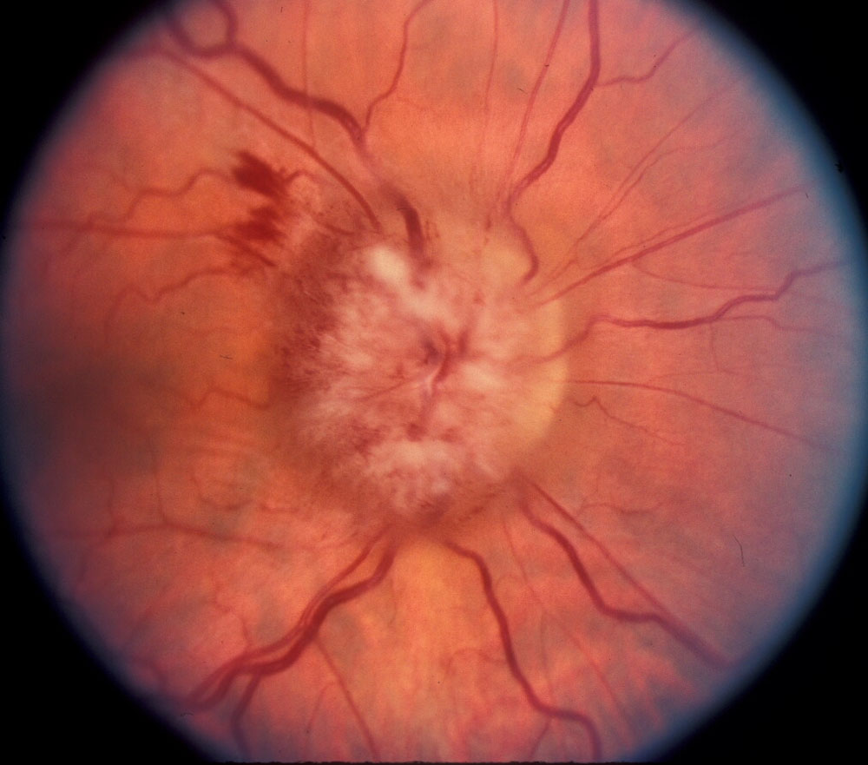

Situational task number 4

Assessed competencies: PK-6, PK-8, PK-10

Man A., 46 years old. Complaints of a sharp decrease in vision of the left eye. In the morning, vision was normal. During work, I noticed that the left eye suddenly began to see poorly. The decrease in vision was not accompanied by pain. In 5-10 minutes, the eye completely went blind. The patient suffers from hypertension. Objectively. Visual acuity of the right eye = 1.0. The eye is calm. Anterior segment of the eye without visible changes. Optical media are transparent. On the fundus picture of hypertensive angiosclerosis. Visual acuity of the left eye = 0. The left eyeball is not injected. Anterior segment of the eye without visible changes. Optical media are transparent. On the fundus is determined clouded pale retina. Against her background, a bright red central fossa stands out in the area of ​​the macula lutea. Arteries are sharply narrowed. Intermittent arteries have broken blood columns. Veins are practically unchanged. The optic nerve disc is pale with a gray tint.

The questions

1. Make a diagnosis.
2. What additional research is needed?
3. Describe the treatment

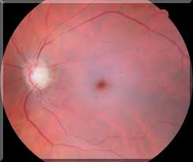

Situational task number 5

Assessed competencies: PK-6, PK-8, PK-10

Patient B., 9 years old, complains of low vision in both eyes. According to the mother, she sees poorly from birth. He does not use glasses - they do not help. Objectively. Visual acuity of both eyes = 0.1 (n / a) anterior segment unchanged. On the fundus of the optic nerve discs are pale, somewhat reduced in size. No other pathology is visible. Pushed horizontal swinging eye movements.

The questions

1. Make a diagnosis.
2. What additional research is needed?
3. Prescribe a treatment

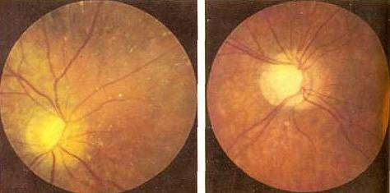

Situational task number 6

Assessed competencies: PK-6, PK-8, PK-10

Patient N., 59 years old, in the cardiology department, with ophthalmoscopy: retinal veins dilated, convoluted. Arteries are somewhat narrowed, uneven caliber. Positive symptoms of Guist and Salus - I. Mild hyperemia of the optic disc. Single point retinal hemorrhage.

The questions

1. The diagnosis.
2. What or what stages of hypertension correspond to these changes?

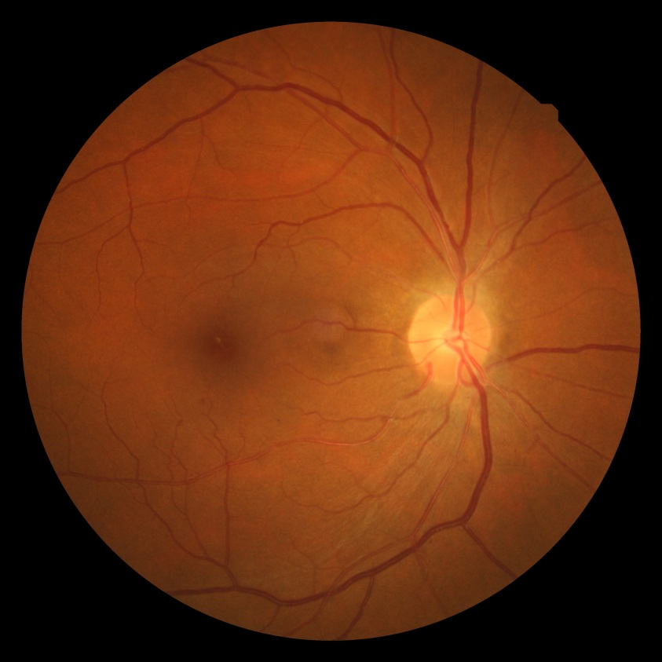
Situational task number 7

Assessed competencies: PK-6, PK-8, PK-10

Patient P., 25 years old, complains of periodic blurred vision of the left eye, frequent headaches. Objectively. Visual acuity of the right eye and left eye = 1.0. The adnexa is not changed. The eye is calm. Anterior segment without pathology. With ophthalmoscopy: optic nerve disc enlarged, mushroom-like promotes in the vitreous, small petechial hemorrhages. The color of the disk is pinkish-gray, the borders are fuzzy. Peripapillary edema is expressed.

The questions

1. Estimated diagnosis.
2. Additional research.
3. Therapeutic measures

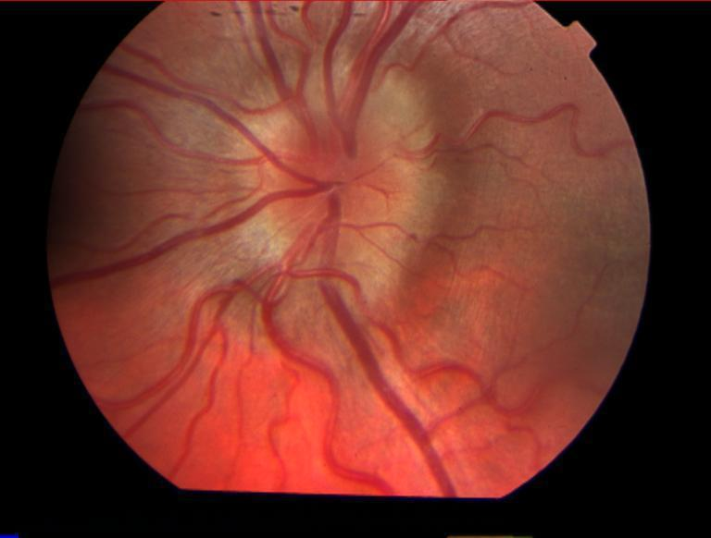

Situational task number 8

Assessed competencies: PK-6, PK-8, PK-10

Child Sh., 4 years old, within 3 months the vision of the right eye sharply decreased. Parents drew attention to the wide "luminous" pupil of this eye. The pain of the child does not bother. When viewed objectively. Visual acuity of the right eye = pr certa. The eye is healthy. Visual acuity of the left eye = 1.0. The adnexa is not changed. The eye is calm. Front segment without visible changes. The pupil is round, dilated, practically does not react to light. Optical media are transparent. Ophthalmoscopy of the right eye: a yellowish-golden tuberous formation that promotes the vitreous body.

The questions

1. Estimated diagnosis.
2. Additional research.
3. Treatment

Situational task number 9

Assessed competencies: PK-6, PK-8, PK-10

An 40-year-old man came to the optometrist with complaints of a gradual narrowing of his visual field. From the anamnesis: the patient’s mother suffered from low vision, the patient’s brother has the same complaints. Anterior segment without pathology. The adnexa is not changed. The eye is calm. Visual acuity of the right eye = 0.6 n / a. Visual acuity of the left eye = 0.6 n / a Ophthalmoscopy of both eyes: the optic disc is waxy in color, the borders are clear, the arteries and veins are narrowed, dystrophic foci in the form of "bone bodies" on the middle and extreme periphery. The static perimetry of both eyes is a narrowing of the visual fields to 15 degrees.

The questions

1. Estimated diagnosis.
2. Additional research.
3. Treatment
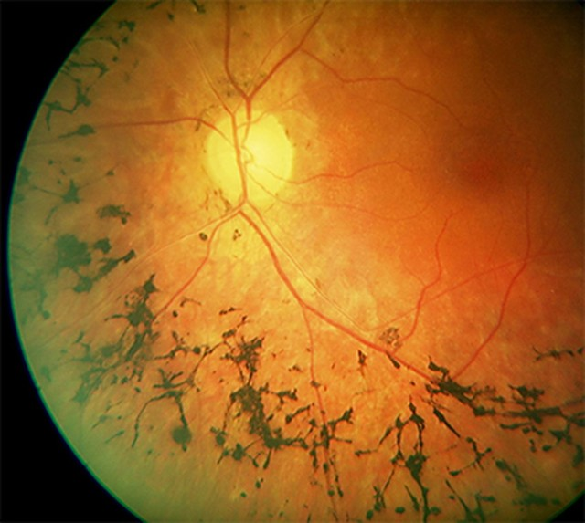

Situational task number 10

Assessed competencies: PK-6, PK-8, PK-10

Patient S., 70 years old, came to see an ophthalmologist with complaints of decreased vision in both eyes. From the anamnesis: phacoemulsification was performed with implantation of IOL of both eyes, surgery and the postoperative period without complications. Anterior segment without pathology. The adnexa is not changed. The eye is calm. The position of the IOL in the posterior chamber, Visual acuity of the right eye = 0.3 n / K. Visual acuity of the left eye = 0.3 n / a Ophthalmoscopy of both eyes: optic discs are pale pink, the borders are clear, the vessels are narrowed sclerotized, in the macular zone there are many dystrophic foci-friends. Static perimetry of both eyes: visual field defect in the central zone. Peripheral Norm

The questions

1. Estimated diagnosis.
2. Perform differential diagnostics.
3. Describe the treatment
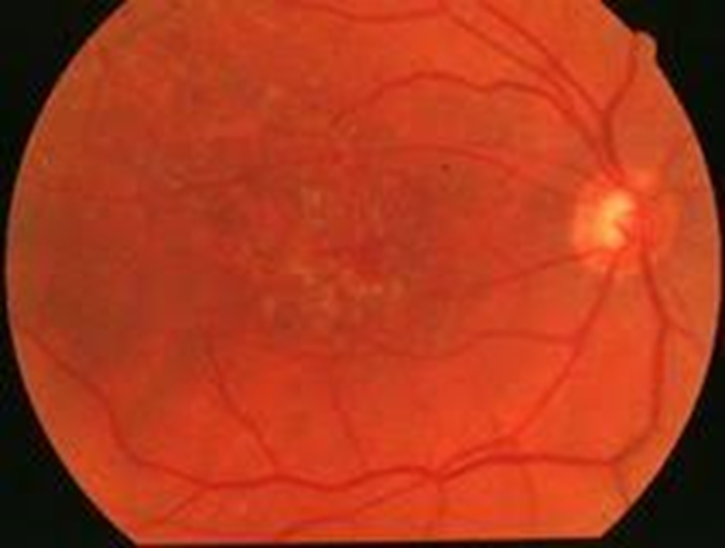

Situational task No. 11

Assessed competencies: PK-6, PK-8, PK-10

Patient G., 50 years old, complaints of decreased vision in both eyes. Anamnesis: suffering from type 2 diabetes mellitus 10 years. Glucose 15 m / mol. Objectively. Visual acuity of the right eye = 0.2 (not corr.), Left eye 0.1 n / a. OD / OS is calm, transparent optical media. The fundus of the eye: the optic nerve disk is pale pink, the borders are clear around the vascular arcades and paramacular on the middle and extreme periphery of the microaneurysm, small point hemorrhages, in the macular exudate zone. TOD = 22 mmHg TOS = 22 mmHg
Questions
1. Make a diagnosis, determine the stage of the disease
2. What treatment is required for the patient, explain.
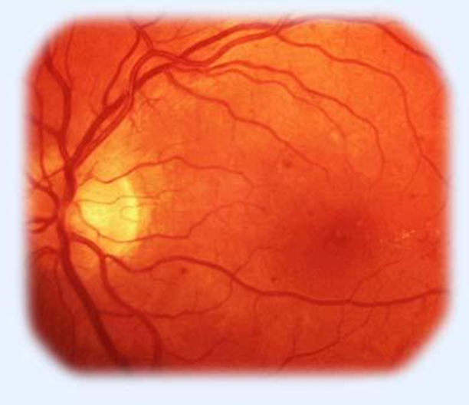

Situational task No. 12
Assessed competencies: PK-6, PK-8, PK-10
Patient S., 63 years old, complaints of decreased vision in both eyes. Anamnesis: has been suffering from diabetes mellitus 2 for more than 15 years. Glucose 12 m / mol, glycated hemoglobin 16 m / mol. Cataract phacoemulsification was performed with IOL implantation in both eyes. Objectively. Visual acuity of the right eye = 0.08 (not corr.), Left eye 0.1 n / a. OD / OS is calm, transparent optical media. The fundus of the eye: the optic disc is pale, there are newly formed vessels around the disc, in the central zone and on the middle periphery there are hemorrhages in the form of “tongues of flame”, IRMA, and edema in the macular zone. TOD = 22 mmHg TOS = 22 mmHg

Questions
1. Make a diagnosis, determine the stage of the disease
2. What treatment is required for the patient, explain.
